# ***Nuvia app report***

# ***User Manual***

# ***Uploading information and accessing reports***

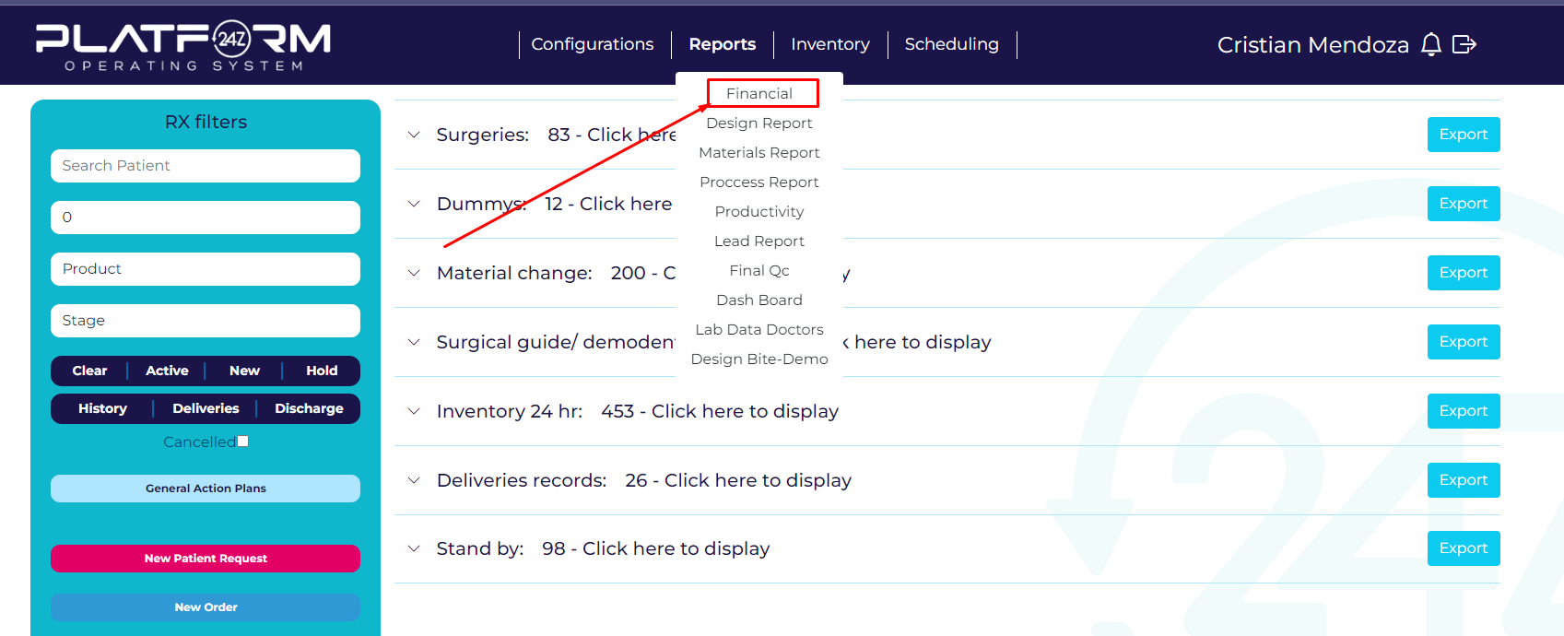

Once logged into the Nuvia platform, go to the reports/Financial section. If this option does not appear, contact the platform team to request the necessary permissions for this action.

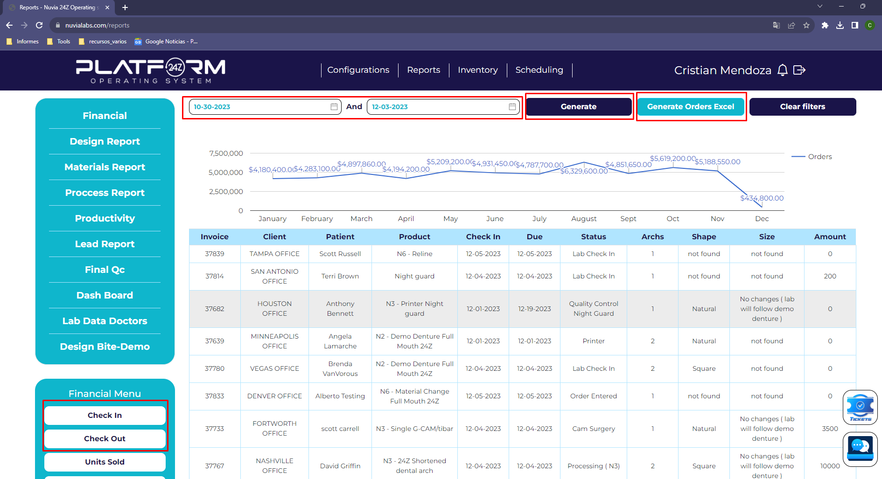

Once you have entered the route of reports/Financial, choose the dates of interest for the month. These can be selected for completed months. Do not forget to click the 'generate' button to query the server for the data. After that, click on 'generate orders excels' for their export. A similar process is required for extracting completed orders in the same time period. To access these, select the 'Check Out' option in the Financial Menu located at the bottom left of the screen.

For example, for studying the performance, metrics, and products of the laboratories in November 2023, select the dates between October 30 and December 3 for a proper weekly study. These dates are available within the 'documentation' folder if you need to know the specific week-to-week boundaries of the reports. Once the correct time interval is selected.

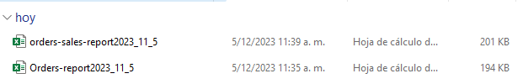

Once this information is exported, rename the Excel files as follows:

- "Orders-report_YYYY_MM_DD" will become "week_"

- "orders-sales-reportYYYY_MM_DD" will become "week_finished_"

This way, the software will identify which file corresponds to each type of order.

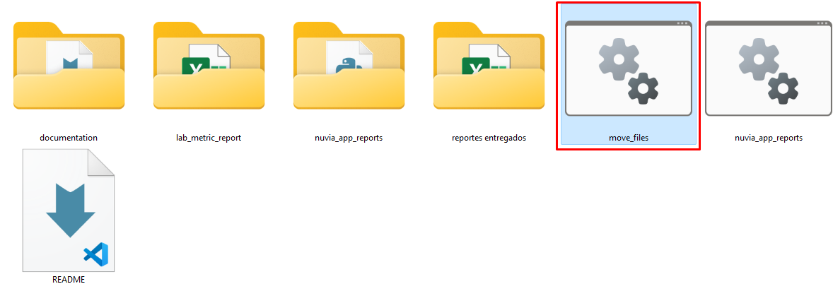

Now, with the files inside the NUVIA REPORTS folder, you will need to move these files to the corresponding year and month folder. To do this, double-click on the move_files.bat file and enter the appropriate year and month numbers. The program will then move the files to their respective locations.

For our example, this action takes the following form:

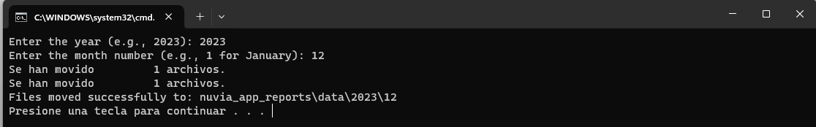

Once the files are located in their respective paths, you can use the respective reports by clicking on nuvia_app_reports.bat. That is:

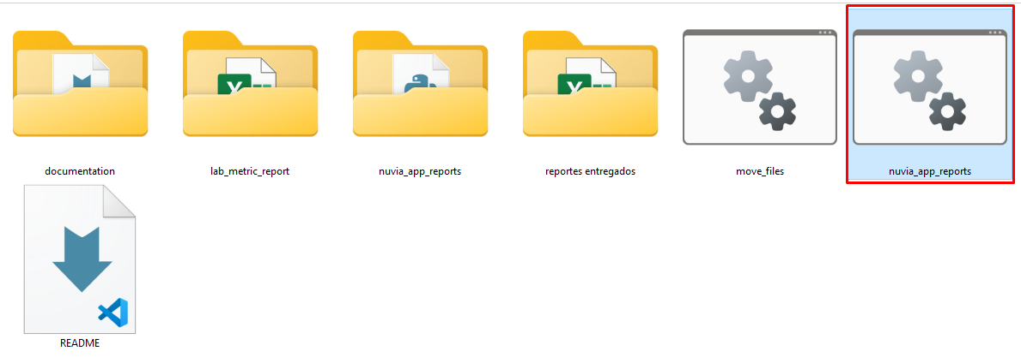

Which will display a terminal with the different options for the respective reports:

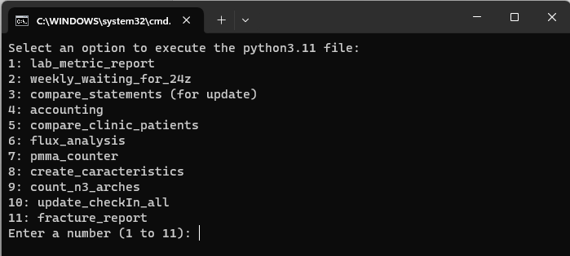

Locating the report you want to obtain, select its ID number, and access those reports located in the ".\nuvia_app_reports\results" path.